iLAB – AERO Team

Prerequisites before coming to iLAB
- Host mac address should be added in Cobbler.
- All the host OS install via Cobbler on server.
- The Host boot order priority should be Cobbler PXE
- For Host OS installation, the KS changes for ssh and make the changes.
- All the host OS iso should be present in the Cobbler PXE.
Get Hosts point to Cobbler
- In Cobbler system configuration the Name, profile and NetBoot_Enabled should be added.
- In profiles, the profile should be there for host OS.
Get Testbed cabled together

- E2E (host / clusters/ switch) connectivity between the gears should be enabled.
Configuration Creation in iLAB

Go to iLAB home page. Select the test bed location.
And then select “Submit new Job”.
Select create a new configuration and give the name for new configuration.

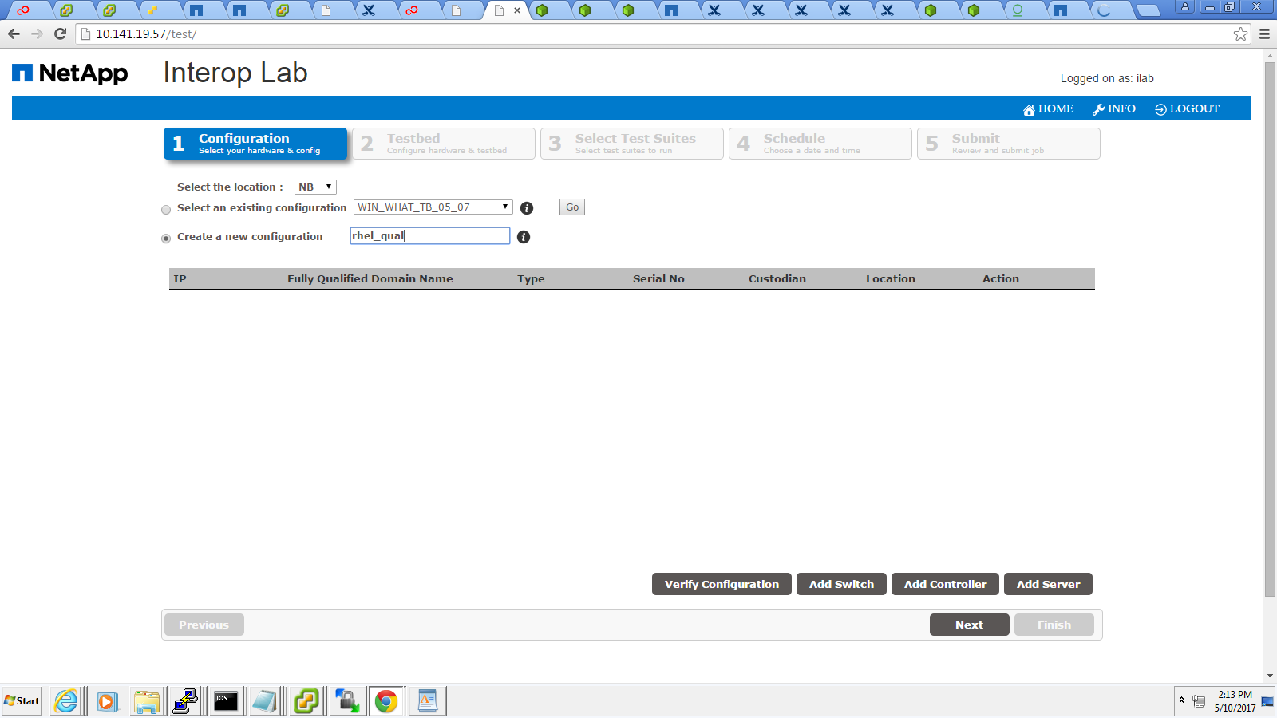

Add Server:

Select “Add server”

The pop up displayed to add the server details.
Provide the IP address and select “LOAD” button.

The page will be loaded with FQDN, MAC address & which cards installed on the server.

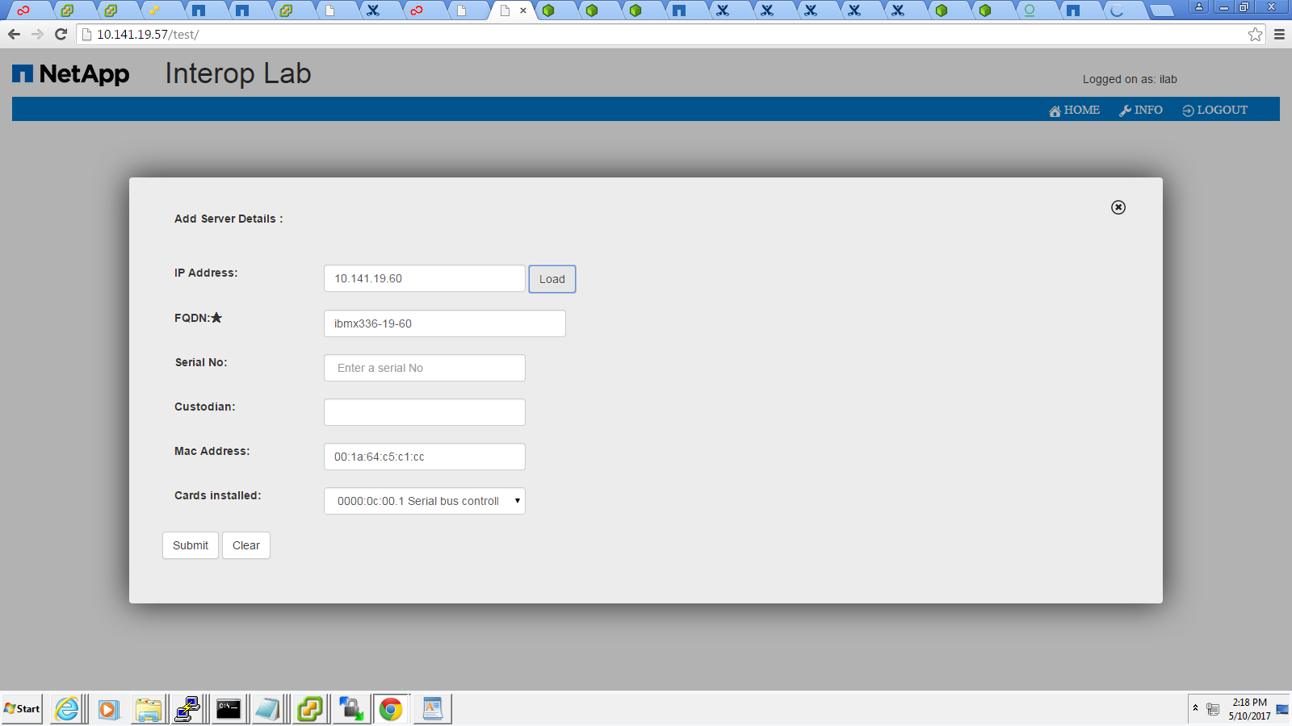

Then select submit button.

Add Controller: (minimum one HA pair- 2node)

Select Add controller.
The pop up displayed to add the controller details.
Provide the IP address, FQDN and select submit button.

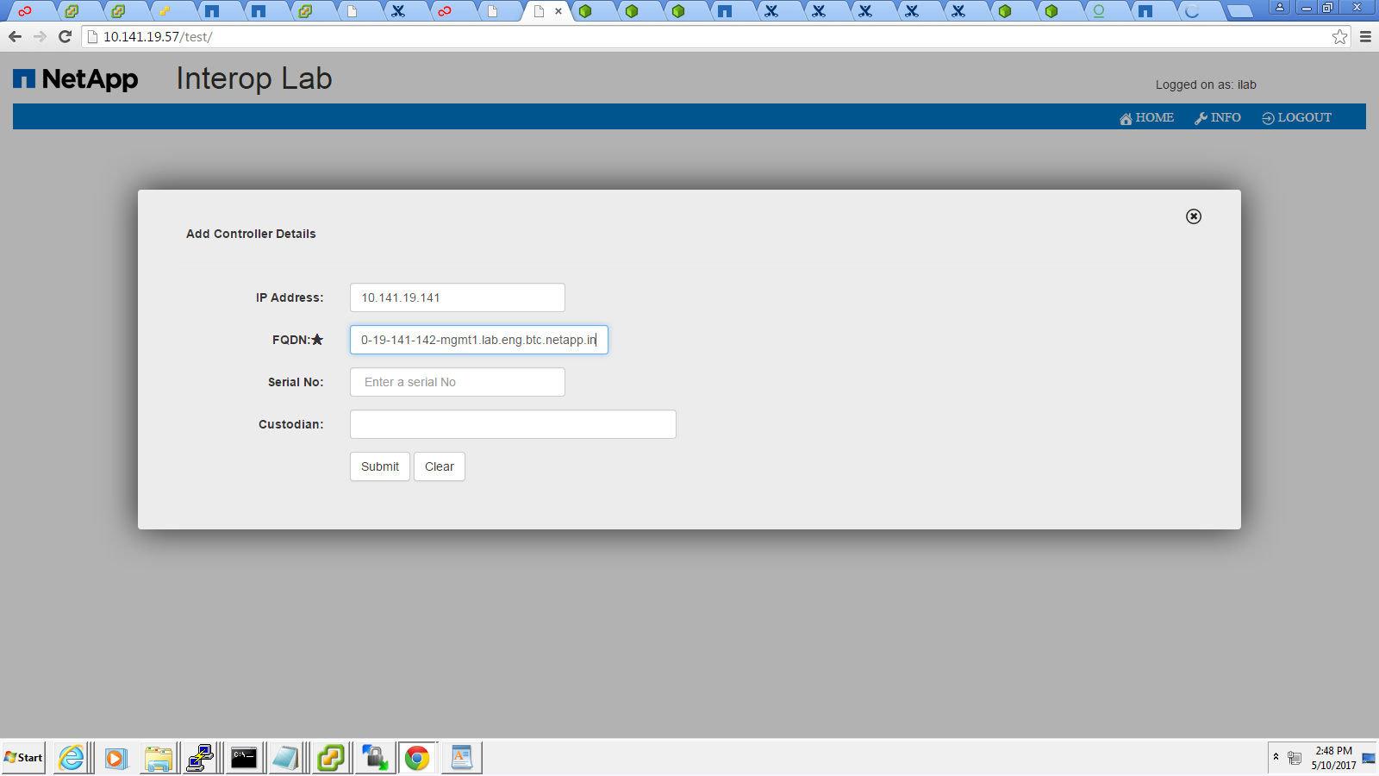

Add the other node as well.

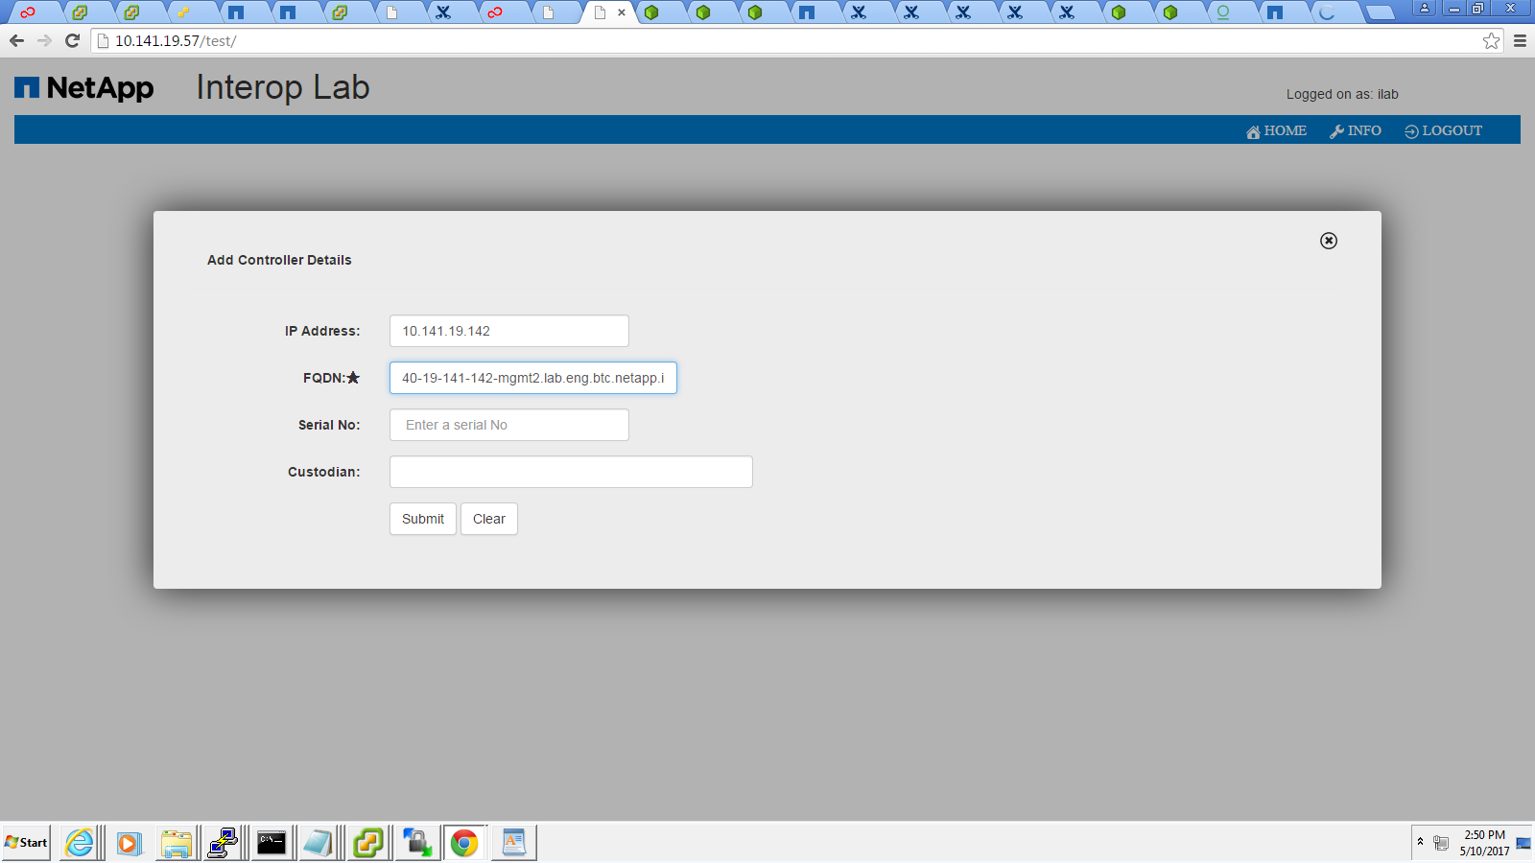

Add Switch:

Select Add switch.
The pop up displayed to add the switch details.
Provide the IP address, FQDN and select submit button.

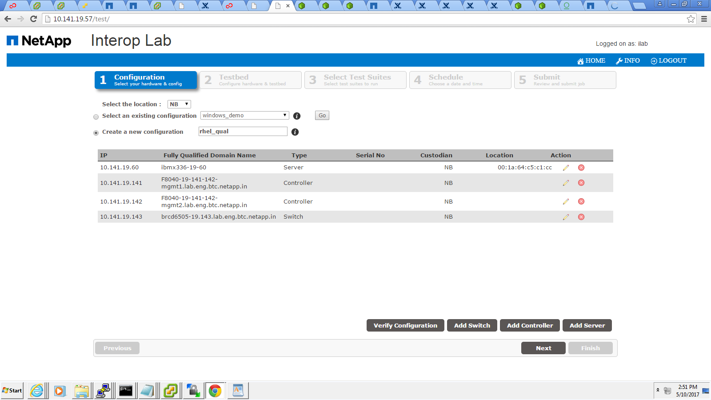

Verify Configuration:
Select verify configuration button.

This will verify all the gears are alive or not

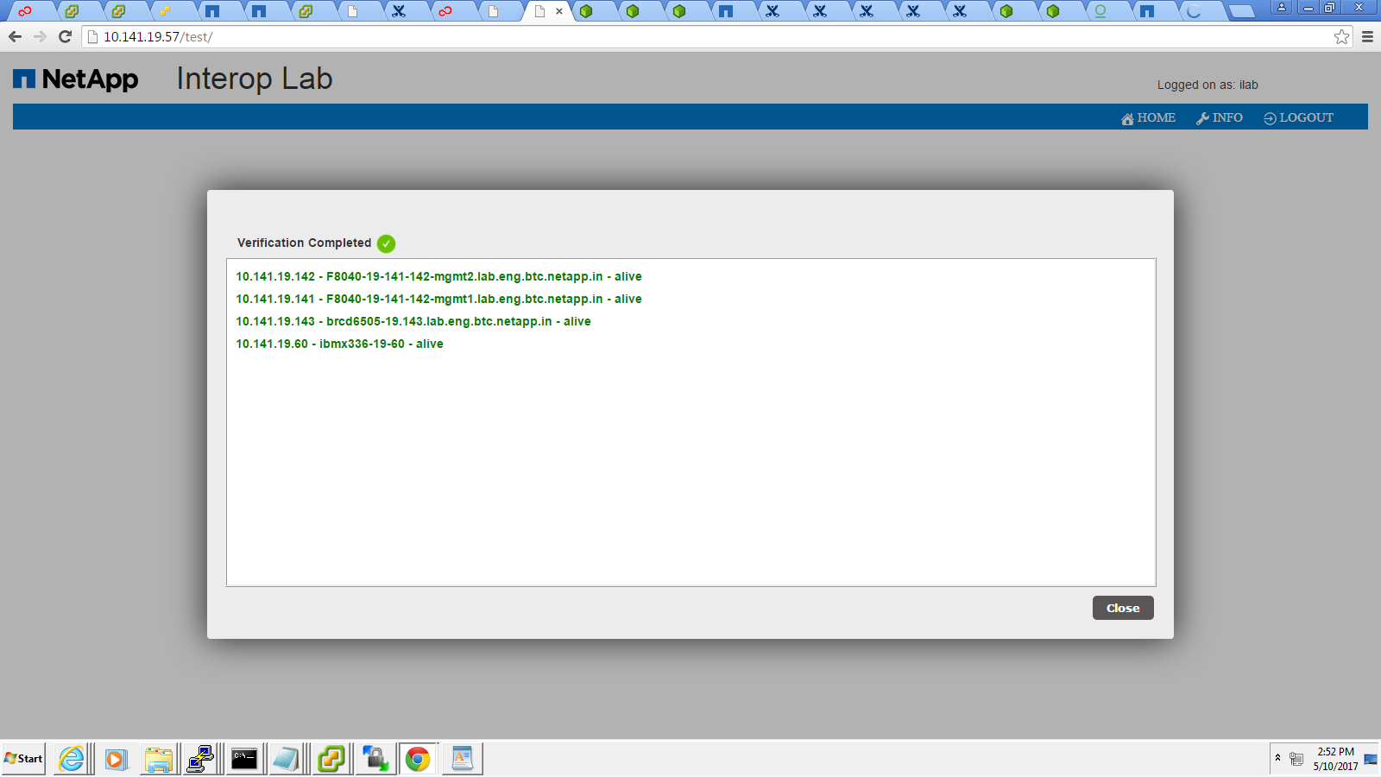
Then click next button.

Select create a new test bed with the name.

Configure host:

Select the host OS which you want to test.
Select the PXE/Cobbler.

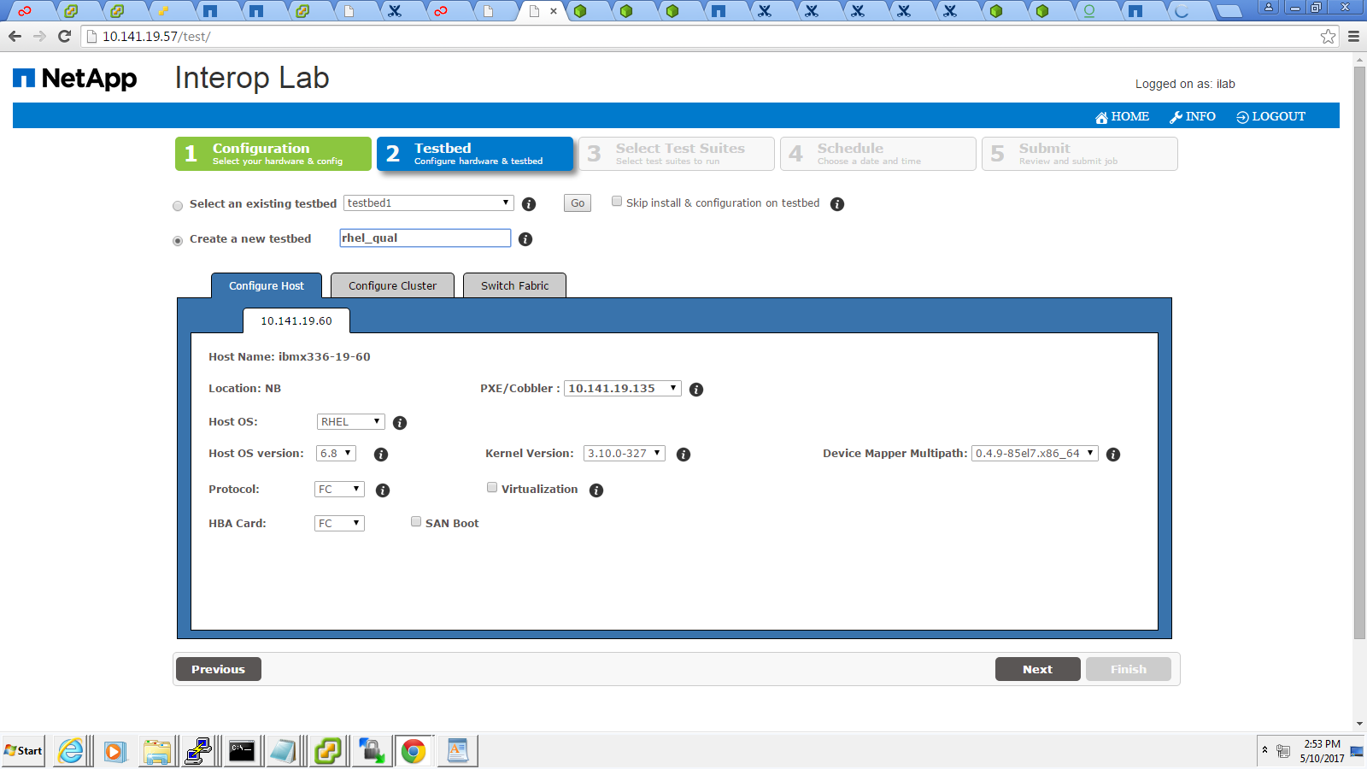

Configure controller:
Select the storage OS which you want to test.
Provide cluster name.
Select the partner node.

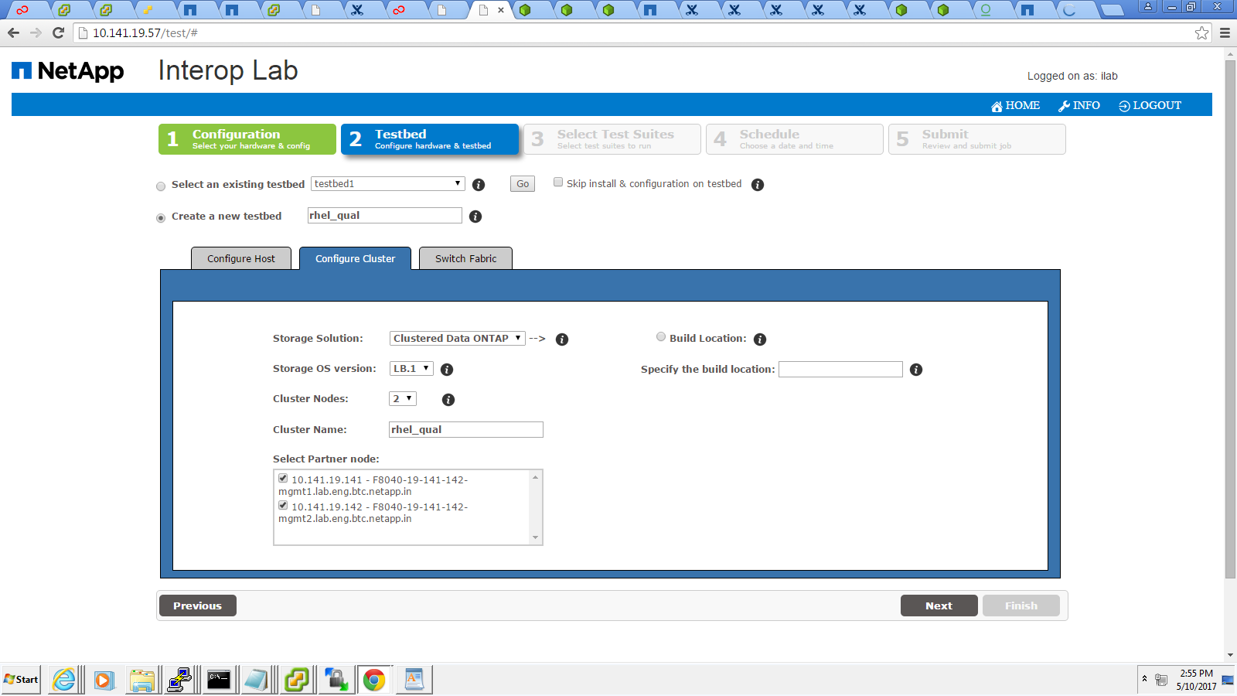

Switch fabric:

Verify the switch details are present in the page.

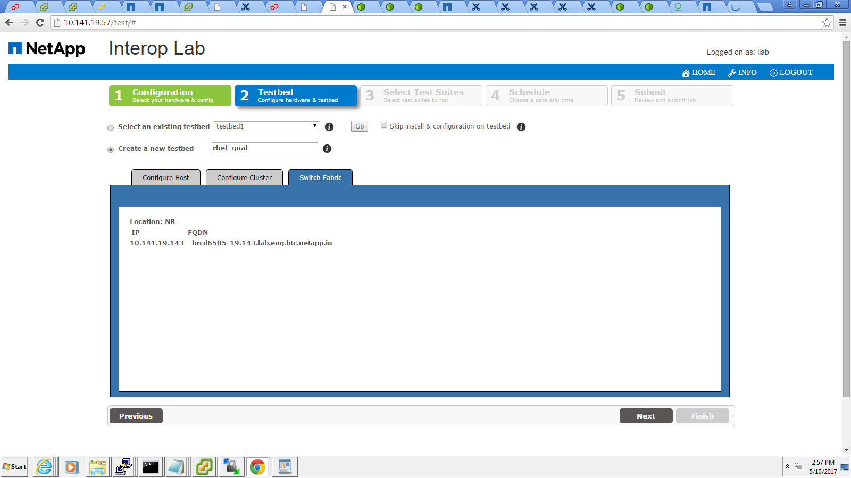

Then select next button.

Select the test cases which you need to run. Move from available test cases to selected test cases.

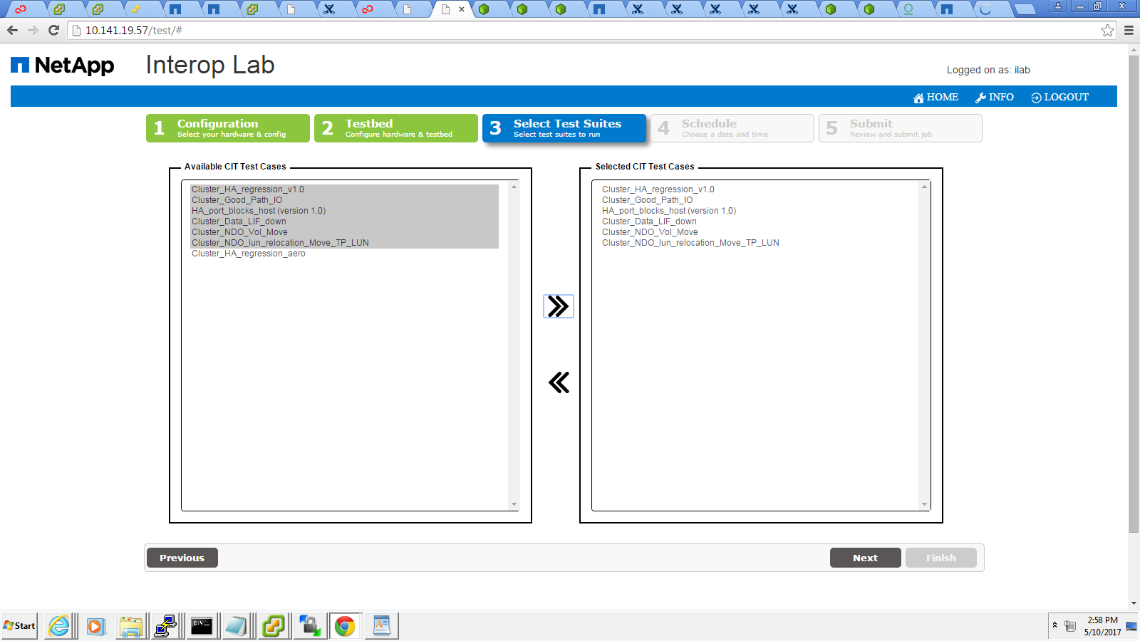

Then select next button.

Schedule the Job :

The user has the option to schedule the job now or later.

If the user selects later, he/ she should select the start date and time with time stamp IST or EST.

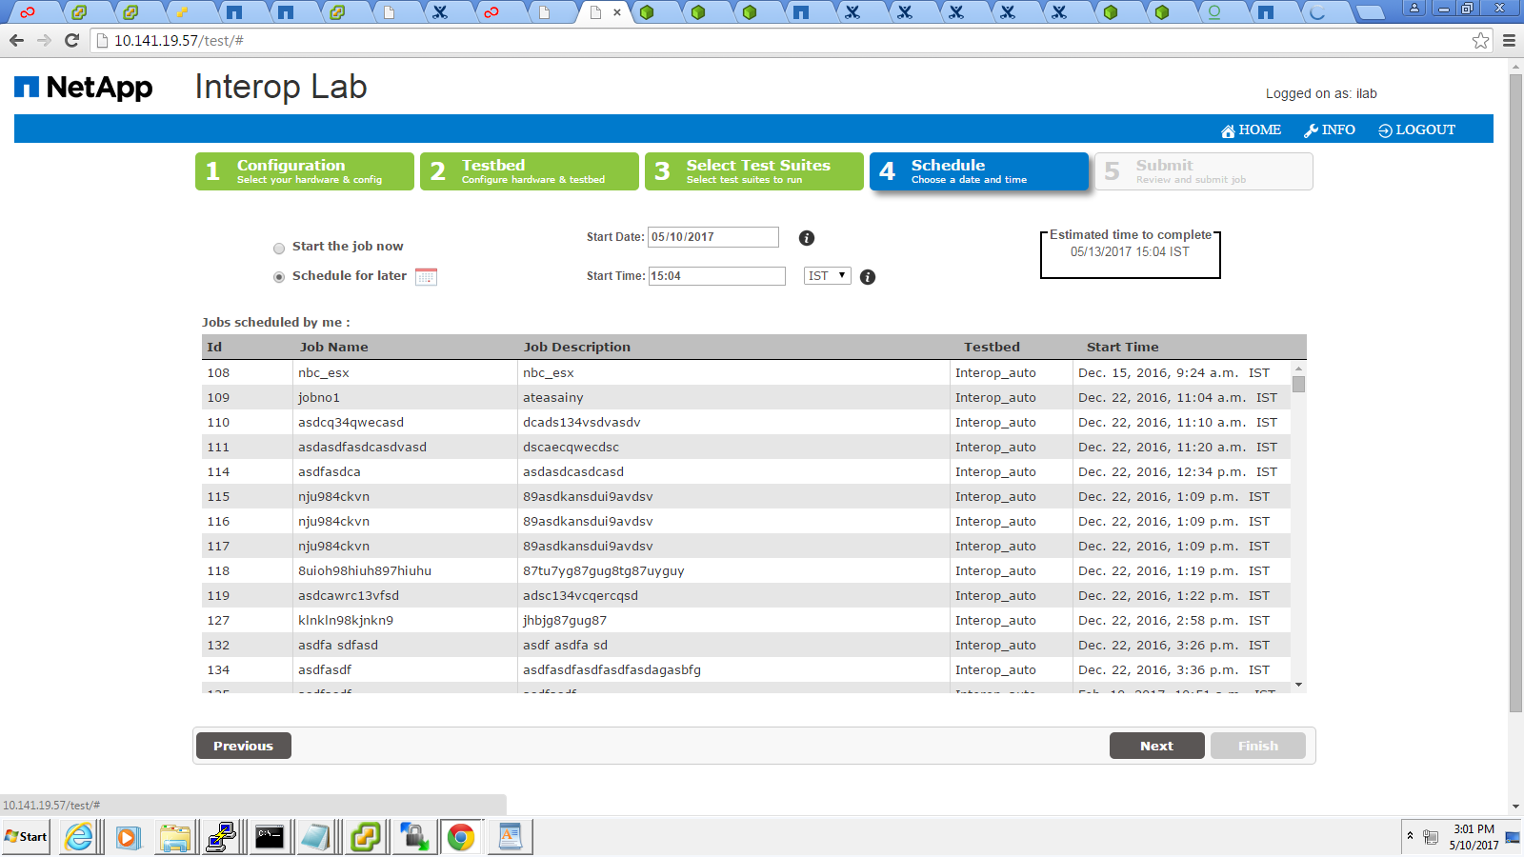

Then click next button.

Submitting a Job in iLAB

For submitting the Job, the user should mention the Job name and description.

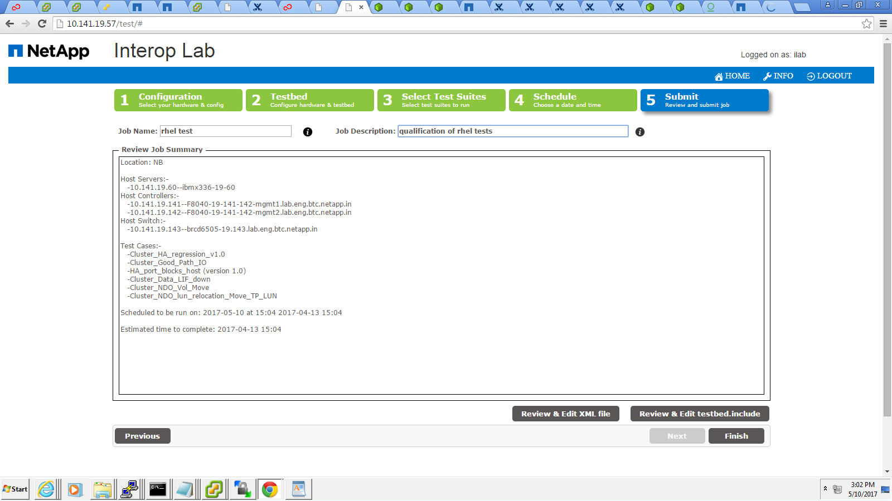

The user have the option to review & edit the xml and testbed. include file.
Any discrepancy in both the files,the user can modify the changes and click save button.

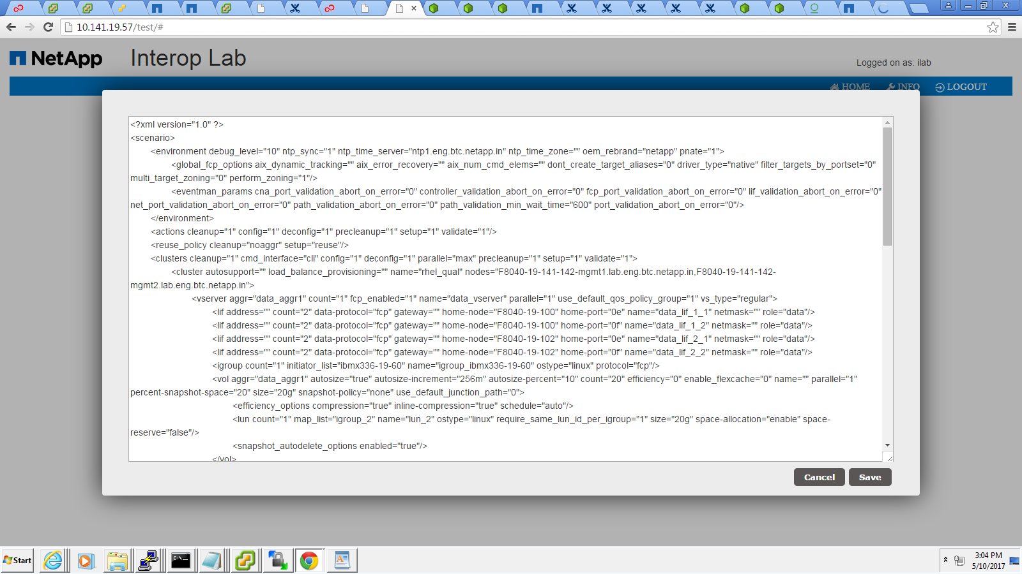

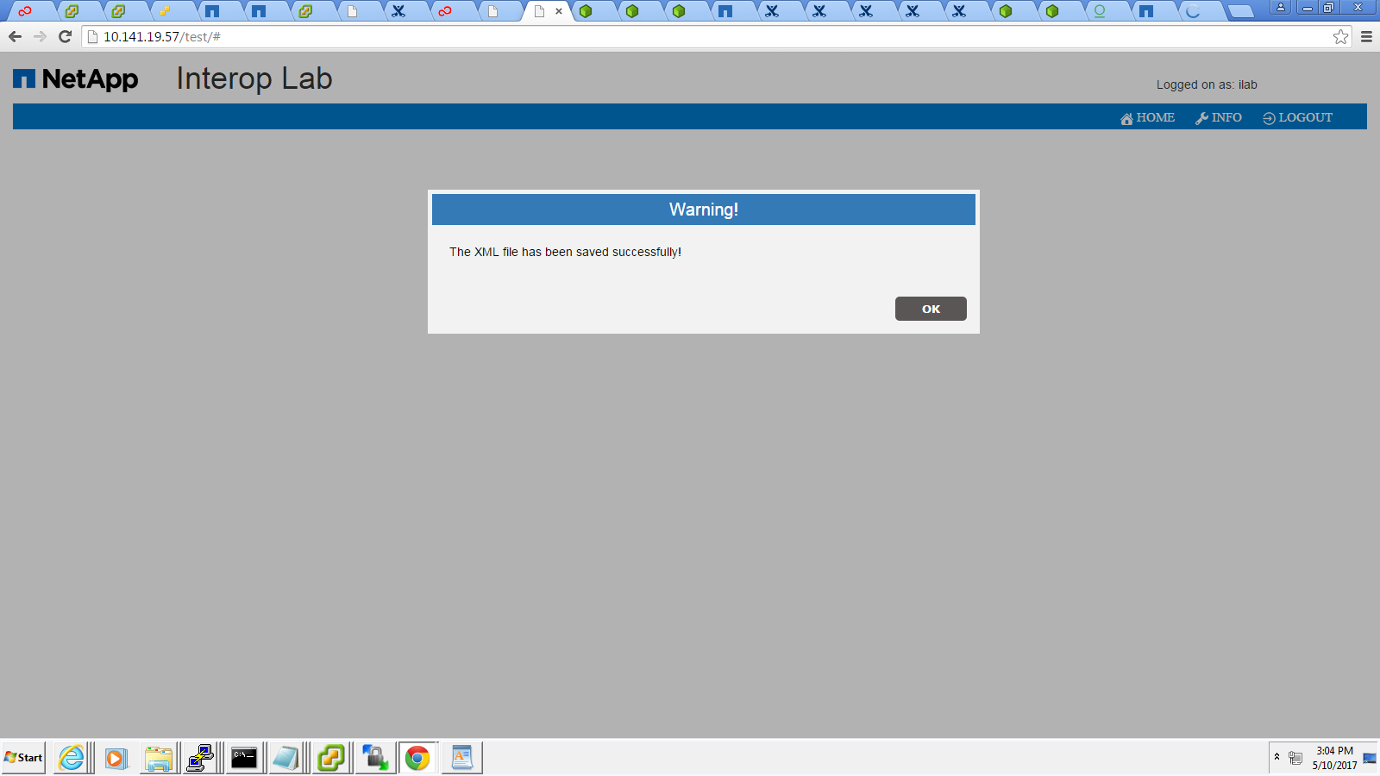

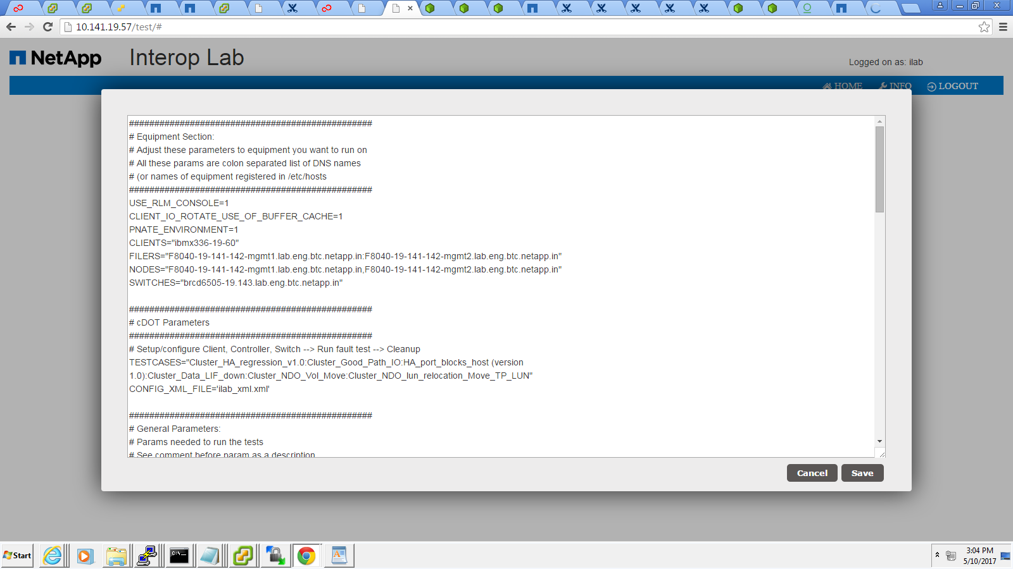

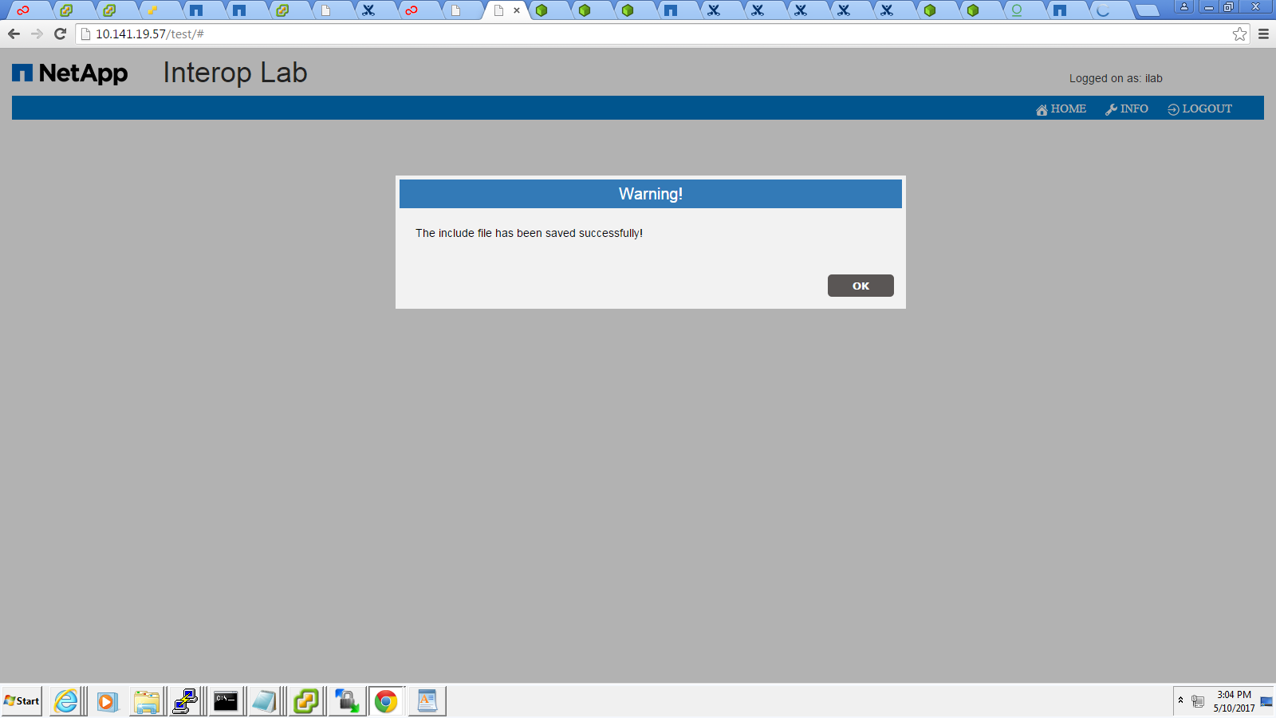

Then click Finish button.
The job has been added successfully.

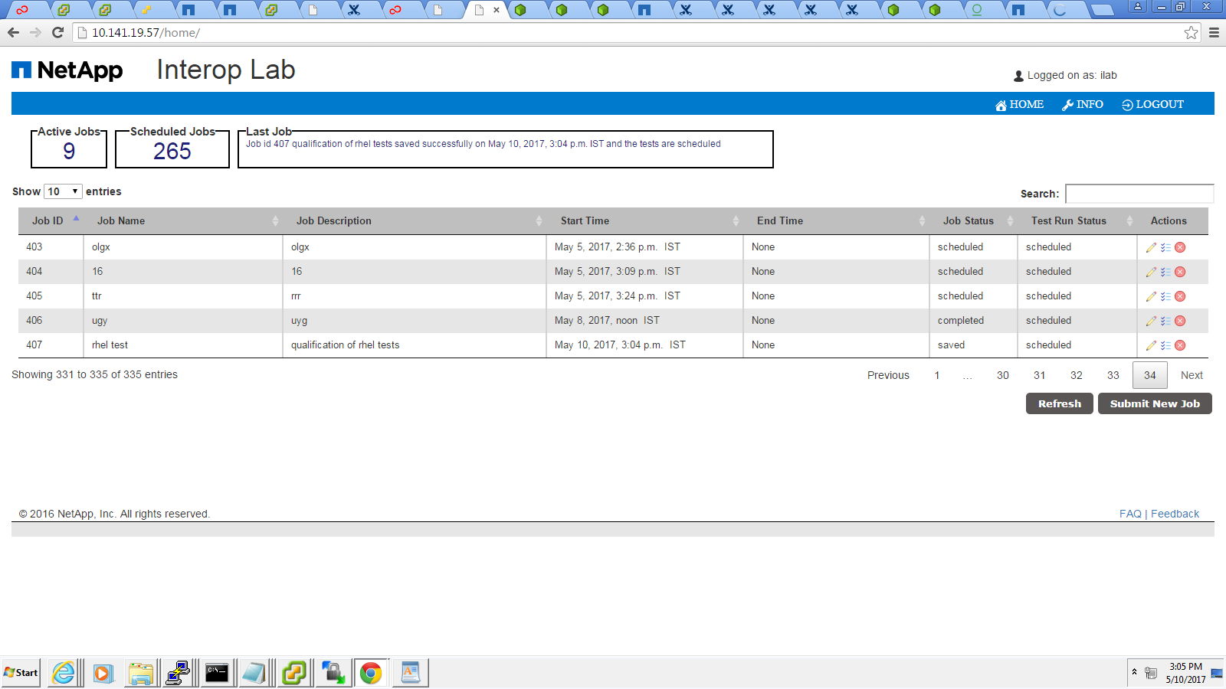

Issues found:
- HUT Installation failed: Failed to install HBA QLogic QLE2562 driver
Latest support DW/FW in HUT for Windows 2012R2 / Windows 2016 – code has to be check in to the P4.

- GX Boot failed for controllers RLM / SP IP.RLM ip has been reconfigured and have provided in the controllers tharnhosts file.
RLM_ENABLED=1
RLM_GATEWAY=
RLM_IP=
RLM_MASK=

